<page_start no = 1>
<sol_start id=1>
1. ……
a =
d =
=
a_{n} = a + (n – 1)d
a₁₀₀ = + (100 – 1)
= +
=
<sol_end>

<sol_start id=2>
2. A circle can have an infinite number of tangents
<sol_end>

<sol_start id=3>
3. n^{th} – term of AP = 8n – 5
a = 8(1) – 5
= 3
Last term in 28th term
l = 8(28) – 5
= 219
= 3108
<sol_end>

<sol_start id=4>
4. OP = OQ (Radii of same circle)
∴ ΔPOQ is an isoceles triangle
∠OPQ = OQP
OP ⊥ PT
∠OPT = 90°
∠OPQ + QPT = 90
55° + ∠TPQ = 90°
∠TPQ = 90° – 55°
= 35°
<sol_end>
<page_end>

<page_start no = 2>
<sol_start id=5>
5. AP : 3, 15, 27, 39,……
a = 3, d = 15 – 3
= 12
a_{n} = a + (n – 1)d
n = 54
n₅₄ = 3 + (54 – 1)12
= 639
Term which is 132 more than 54th term is
639 + 132 = 771
a_{n} = 771
771 = a + (n – 1)d
771 = 3 + (n – 1)12
n = 65
<sol_end>

<sol_start id=6>
6. PR = 12 cm, OP = 5 cm and OQ = 4 cm
OP = OQ + OP
OP = 4 + 5
= 9 cm
RO² = PR² + OP²
RO² = 12² + 5²
RO = 15 cm
RQ² = RO² – OQ²
RQ² = 15² – 42
RQ = cm
OP = 5 cm
RO² = PR² + OP²
RO² = 15²
RO = 13 cm
RQ² = RO² – OQ²
RQ² = 13² – 4²
RQ = cm
<sol_end>

<sol_start id=7>
7. Lowest 3 digit number = 87 × 2
= 174
Highest 3 digit number = 87 × 11
= 957
l = a + (n – 1)d
957 = 174 + (n – 1)87
n = 10
<sol_end>
<page_end>

<page_start no = 3>
<sol_start id=8>
8. OP = 10 cm
OT = 8 cm
OT ⊥ PT
Radius = 8 cm
In ΔOTP
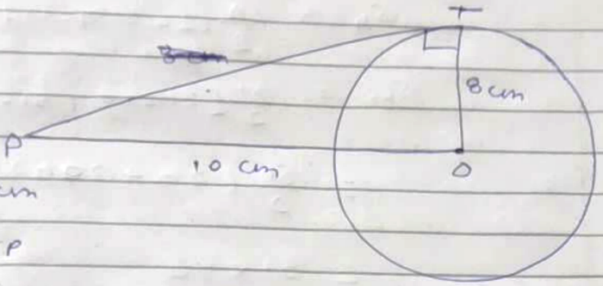
Using Pythagoras Theorem
OP² = OT² + PT²
10² = 8² + PT²
PT² = 10² – 8²
PT² = 100 – 364
= 36
PT = 6 cm
Length of tangent = 6 cm
<sol_end>

<sol_start id=9>
9. a₂ = 14 a₃ = 18
a + d = 14 …(1) a + 2d = 18 …(2)
d = 4
Putting value of d in eq (1)
a + 4 = 14
a = 10
= (20 + 200)
= 51 × 110
S₅₁ = 5610
<sol_end>

<sol_start id=10>
10. ABCD is a parallelogram circumscribed in circle
AB = CD …(1)
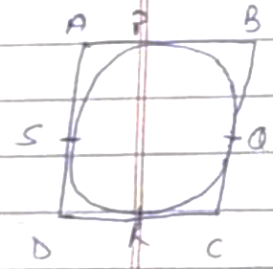
BC = AD …(2)
(tangents on the circle from the point are same)
Adding all these equations we get
DR + CR + BP + AP = DS + CQ + BQ + AS
CD + AB = AD + BC

Putting the value of eq (1) and (2)
2AB = 2BC
AB = BC …(3)
From eq (1) (2) and (3) we get
AB = BC = CD = DA
∴ ABCD is a Rhombus
<sol_end>
<page_end>

